**Certification:**

This was a basic problem solving certification exam on hackerrank coding platform.

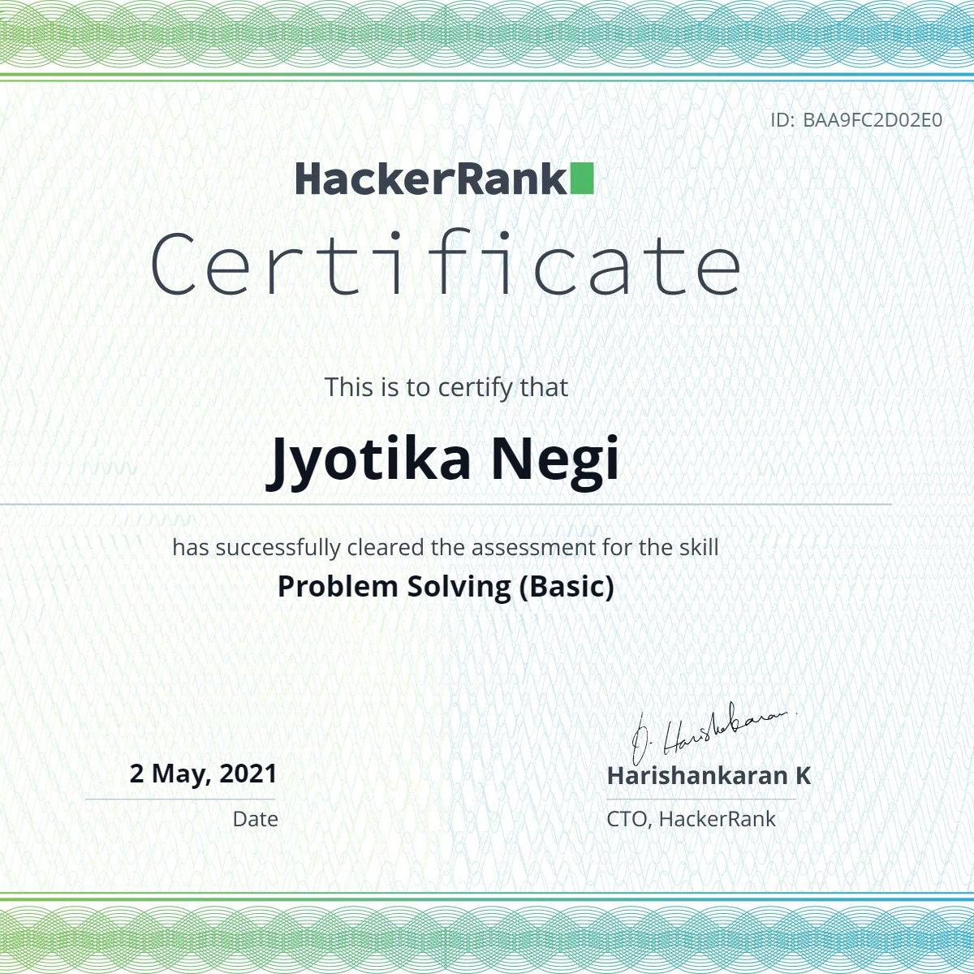

**Participated in hackathon:**

This hackathon was for an internship and the topic for this internship was Deep learning.

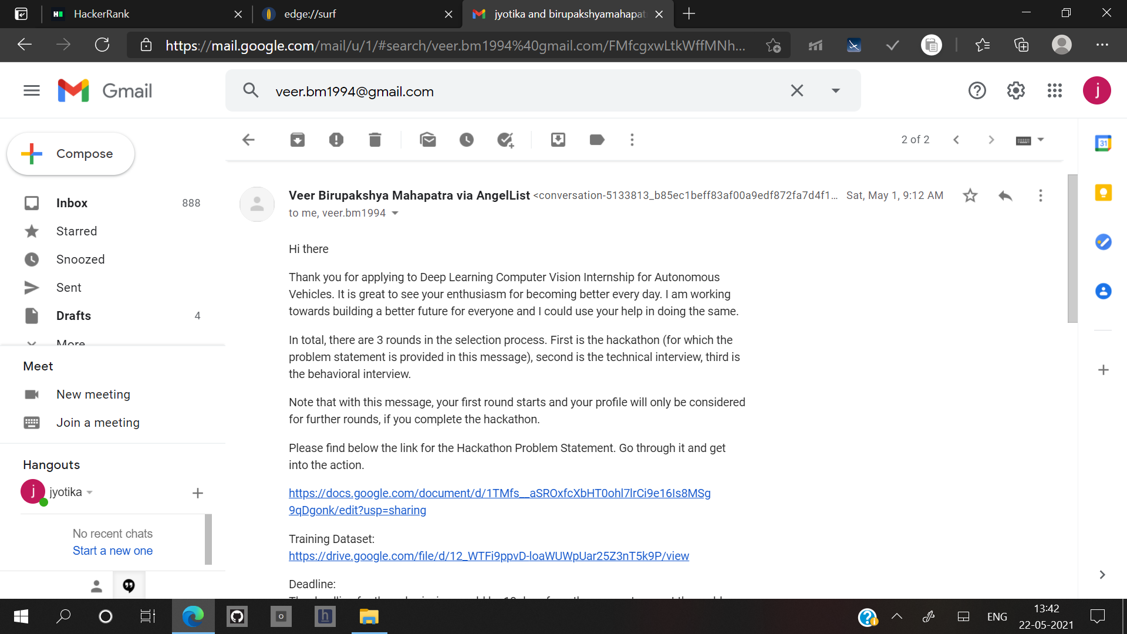

**Internship**

This was a winter internship under hackercode.



**Project:**

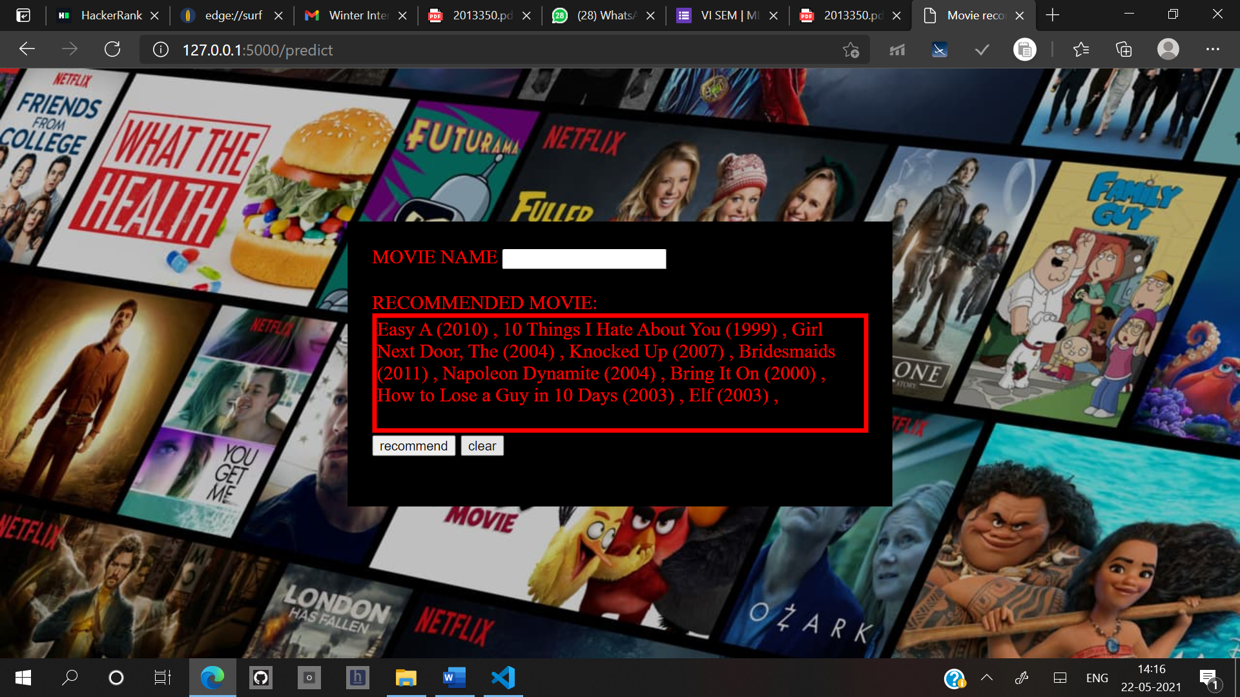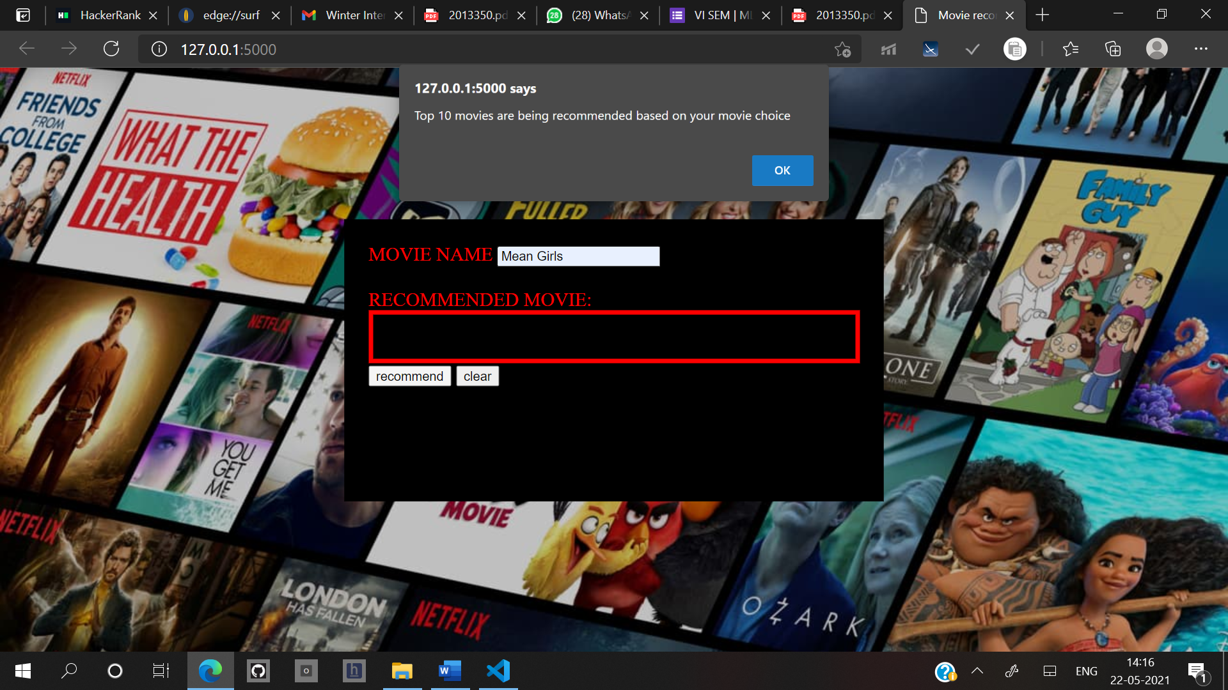This project that I made was recommendation system and implemented in flask this is a part of my on going flask